Fundamentals of Capital Budgeting
8-2. Kokomochi is considering the launch of an advertising campaign for its latest dessert product, the Mini Mochi Munch. Kokomochi plans to spend $5 million on TV, radio, and print advertising this year for the campaign. The ads are expected to boost sales of the Mini Mochi Munch by $9 million this year and by $7 million next year. In addition, the company expects that new consumers who try the Mini Mochi Munch will be more likely to try Kokomochi’s other products. As a result, sales of other products are expected to rise by $2 million each year.
Kokomochi’s gross profit margin for the Mini Mochi Munch is 35%, and its gross profit margin averages 25% for all other products. The company’s marginal corporate tax rate is 35% both this year and next year. What are the incremental earnings associated with the advertising campaign?

8-3. Home Builder Supply, a retailer in the home improvement industry, currently operates seven retail outlets in Georgia and South Carolina. Management is contemplating building an eighth retail store across town from its most successful retail outlet. The company already owns the land for this store, which currently has an abandoned warehouse located on it. Last month, the marketing department spent $10,000 on market research to determine the extent of customer demand for the new store. Now Home Builder Supply must decide whether to build and open the new store.
Which of the following should be included as part of the incremental earnings for the proposed new retail store?
a. The cost of the land where the store will be located.
b. The cost of demolishing the abandoned warehouse and clearing the lot.
c. The loss of sales in the existing retail outlet, if customers who previously drove across town to shop at the existing outlet become customers of the new store instead.
d. The $10,000 in market research spent to evaluate customer demand.
e. Construction costs for the new store.
f. The value of the land if sold.
g. Interest expense on the debt borrowed to pay the construction costs.

8-4. Hyperion, Inc. currently sells its latest high-speed color printer, the Hyper 500, for $350. It plans to lower the price to $300 next year. Its cost of goods sold for the Hyper 500 is $200 per unit, and this year’s sales are expected to be 20,000 units.
a. Suppose that if Hyperion drops the price to $300 immediately, it can increase this year’s sales by 25% to 25,000 units. What would be the incremental impact on this year’s EBIT of such a price drop?
b. Suppose that for each printer sold, Hyperion expects additional sales of $75 per year on ink cartridges for the next three years, and Hyperion has a gross profit margin of 70% on ink cartridges. What is the incremental impact on EBIT for the next three years of a price drop this year?
8-6. Cellular Access, Inc. is a cellular telephone service provider that reported net income of $250 million for the most recent fiscal year. The firm had depreciation expenses of $100 million, capital expenditures of $200 million, and no interest expenses. Working capital increased by $10 million. Calculate the free cash flow for Cellular Access for the most recent fiscal year.
8-7. Castle View Games would like to invest in a division to develop software for video games. To evaluate this decision, the firm first attempts to project the working capital needs for this operation. Its chief financial officer has developed the following estimates (in millions of dollars):
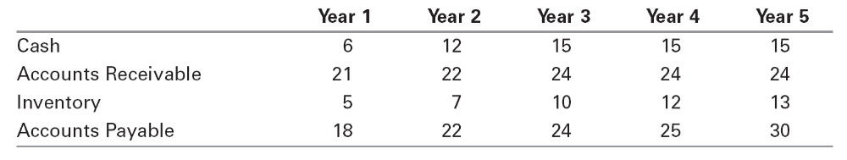
8-8. Mersey Chemicals manufactures polypropylene that it ships to its customers via tank car. Currently, it plans to add two additional tank cars to its fleet four years from now. However, a proposed plant expansion will require Mersey’s transport division to add these two additional tank cars in two years’ time rather than in four years. The current cost of a tank car is $2 million, and this cost is expected to remain constant. Also, while tank cars will last indefinitely, they will be depreciated straight-line over a five-year life for tax purposes. Suppose Mersey’s tax rate is 40%. When evaluating the proposed expansion, what incremental free cash flows should be included to account for the need to accelerate the purchase of the tank cars?

8-9. Elmdale Enterprises is deciding whether to expand its production facilities. Although long-term cash flows are difficult to estimate, management has projected the following cash flows for the first two years (in millions of dollars):
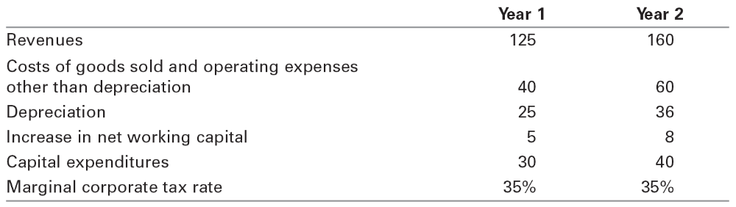
a. What are the incremental earnings for this project for years 1 and 2?
b. What are the free cash flows for this project for the first two years?
8-10. You are a manager at Percolated Fiber, which is considering expanding its operations in synthetic fiber manufacturing. Your boss comes into your office, drops a consultant’s report on your desk, and complains, “We owe these consultants $1 million for this report, and I am not sure their analysis makes sense. Before we spend the $25 million on new equipment needed for this project, look it over and give me your opinion.” You open the report and find the following estimates (in thousands of dollars):
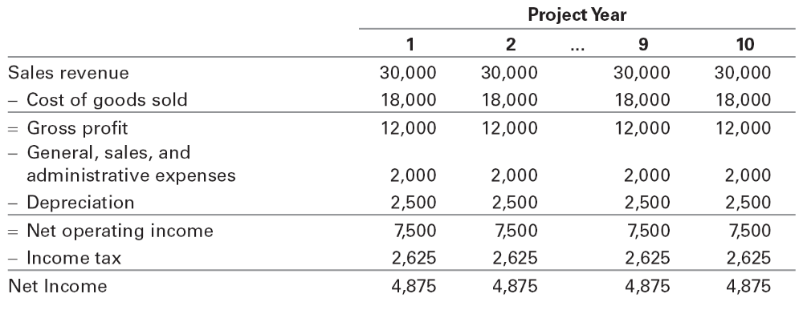
All of the estimates in the report seem correct. You note that the consultants used straight-line depreciation for the new equipment that will be purchased today (year 0), which is what the accounting department recommended. The report concludes that because the project will increase earnings by $4.875 million per year for 10 years, the project is worth $48.75 million. You think back to your halcyon days in finance class and realize there is more work to be done!
First, you note that the consultants have not factored in the fact that the project will require $10 million in working capital upfront (year 0), which will be fully recovered in year 10. Next, you see they have attributed $2 million of selling, general and administrative expenses to the project, but you know that $1 million of this amount is overhead that will be incurred even if the project is not accepted. Finally, you know that accounting earnings are not the right thing to focus on!
a. Given the available information, what are the free cash flows in years 0 through 10 that should be used to evaluate the proposed project?
b. If the cost of capital for this project is 14%, what is your estimate of the value of the new project?

8-19. Bay Properties is considering starting a commercial real estate division. It has prepared the following four-year forecast of free cash flows for this division:
Assume cash flows after year 4 will grow at 3% per year, forever. If the cost of capital for this division is 14%, what is the continuation value in year 4 for cash flows after year 4? What is the value today of this division?

8-20. Your firm would like to evaluate a proposed new operating division. You have forecasted cash flows for this division for the next five years, and have estimated that the cost of capital is 12%. You would like to estimate a continuation value. You have made the following forecasts for the last year of your five-year forecasting horizon (in millions of dollars):
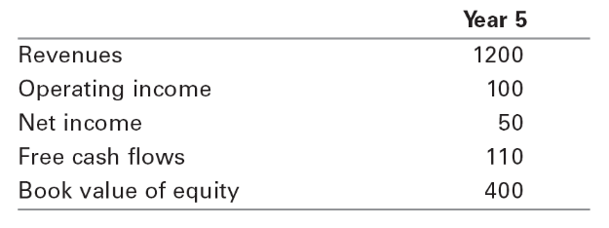
a. You forecast that future free cash flows after year 5 will grow at 2% per year, forever. Estimate the continuation value in year 5, using the perpetuity with growth formula.
b. You have identified several firms in the same industry as your operating division. The average P/E ratio for these firms is 30. Estimate the continuation value assuming the P/E ratio for your division in year 5 will be the same as the average P/E ratio for the comparable firms today.
c. The average market/book ratio for the comparable firms is 4.0. Estimate the continuation value using the market/book ratio.

8.24. Bauer Industries is an automobile manufacturer. Management is currently evaluating a proposal to build a plant that will manufacture lightweight trucks. Bauer plans to use a cost of capital of 12% to evaluate this project. Based on extensive research, it has prepared the following incremental free cash flow projections (in millions of dollars):
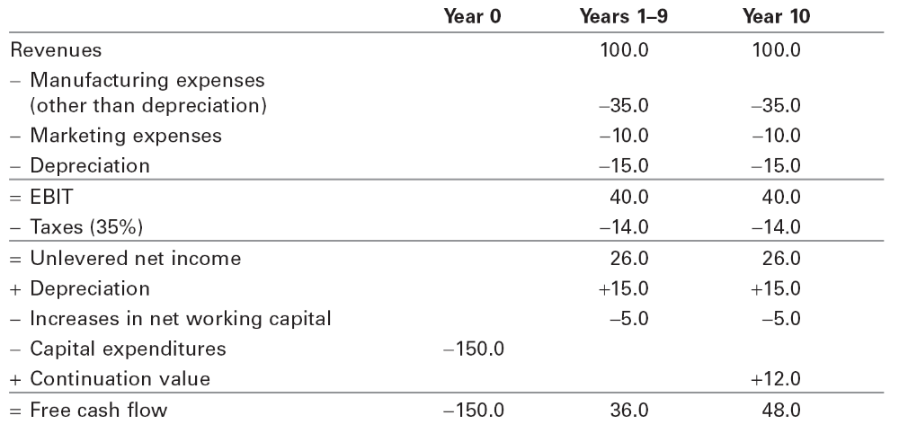
a. For this base-case scenario, what is the NPV of the plant to manufacture lightweight trucks?
b. Based on input from the marketing department, Bauer is uncertain about its revenue forecast. In particular, management would like to examine the sensitivity of the NPV to the revenue assumptions. What is the NPV of this project if revenues are 10% higher than forecast? What is the NPV if revenues are 10% lower than forecast?
c. Rather than assuming that cash flows for this project are constant, management would like to explore the sensitivity of its analysis to possible growth in revenues and operating expenses. Specifically, management would like to assume that revenues, manufacturing expenses, and marketing expenses are as given in the table for year 1 and grow by 2% per year every year starting in year 2. Management also plans to assume that the initial capital expenditures (and therefore depreciation), additions to working capital, and continuation value remain as initially specified in the table. What is the NPV of this project under these alternative assumptions? How does the NPV change if the revenues and operating expenses grow by 5% per year rather than by 2%?
d. To examine the sensitivity of this project to the discount rate, management would like to compute the NPV for different discount rates. Create a graph, with the discount rate on the x-axis and the NPV on the y-axis, for discount rates ranging from 5% to 30%. For what ranges of discount rates does the project have a positive NPV?

